Build-A-Zoo!
Standards:
LIFE SCIENCE (LS) Topic:
Earth’s Living History-This topic focuses on using fossil evidence and living organisms to observe that suitable habitats depend upon a combination of biotic and abiotic factors.
CONTENT STATEMENT: Changes in an organism’s environment are sometimes beneficial to its survival and sometimes harmful. Ecosystems can change gradually or dramatically. When the environment changes, some plants and animals survive and reproduce and others die or move to new locations. An animal’s patterns of behavior are related to the environment. This includes the kinds and numbers of other organisms present, the availability of food and resources, and the physical attributes of the environment.
PHYSICAL SCIENCE (PS)
Topic: Electricity, Heat and Matter This topic focuses on the conservation of matter and the processes of energy transfer and transformation, especially as they apply to heat and electrical energy.
CONTENT STATEMENT:
Energy can be transformed from one form to another or can be transferred from one location to another. Energy transfers from hot objects to cold objects as heat, resulting in a temperature change. Electric circuits require a complete loop of conducting materials through which an electrical energy can be transferred. Electrical energy in circuits can be transformed to other forms of energy, including light, heat, sound and motion. Electricity and magnetism are closely related.

Grade 4
1 Week
Goals:
- Students will be able to model information learned about ecosystems and electricity into a project.
- Students will discover the engineering design process.
- Students will be able to problem solve in a group setting.
Vocabulary:
- Endangered
- Budget
- Grant
- Ecosystem
- Engineering Design Process
- Circuit
- Conductor
Materials:
- Cardboard
- Cardboard cutters
- Safety mats
- Safety gloves
- Duct tape
- Lined paper
- Pencils
- Modeling clay (variety of colors)
- Button batteries
- Copper tape
- LEDs
Outline:
- Introduction: Your challenge is to rescue some endangered species by creating a zoo that mimics their natural ecosystems. In order to complete the challenge you must choose the species of animals that you want to rescue, research their environments and decide what you will need to create. In order to start building, you will need to create a budget and write to the bank to receive your grant of money to start the building process!
- Procedure:
Monday: Choose groups of 2-3 students. Students will choose which species they want to rescue and research their environments.
Tuesday: Students will decide everything that they need to include in each species' environment, and create their budget for materials.
Wednesday: Students will brainstorm then write a persuasive letter to the bank for grant approval. Each will obtain grant approval.
Thursday: Using the Engineering Design Process, students will create a blue print and then build their zoo out of cardboard, duct tape, and modeling clay! If time, they should use the button batteries, copper tape, and LED to add light.
Friday: Students will finish building their zoo and present as a group to the class!
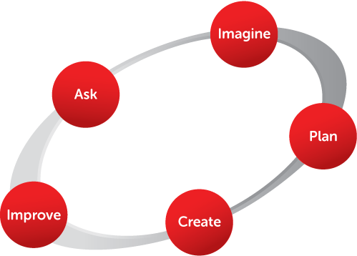

https://eie.org/overview/engineering-design-process

